**Exercise Lab 09**

**Task 1:**

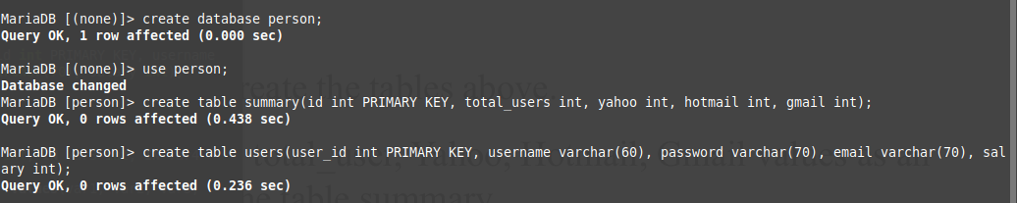

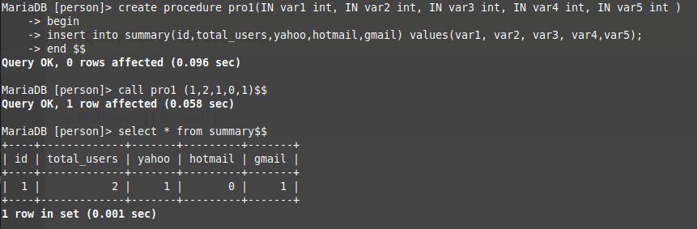

**Task 2:**

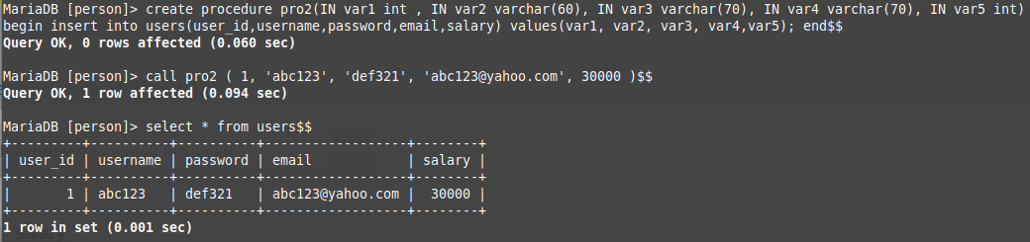

**Task 3:**

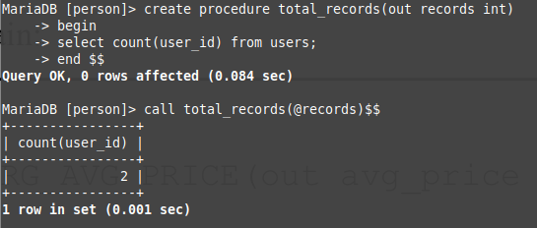

**Task 4:**

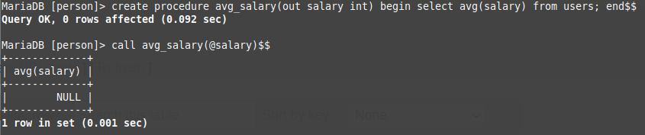

**Task 5:**

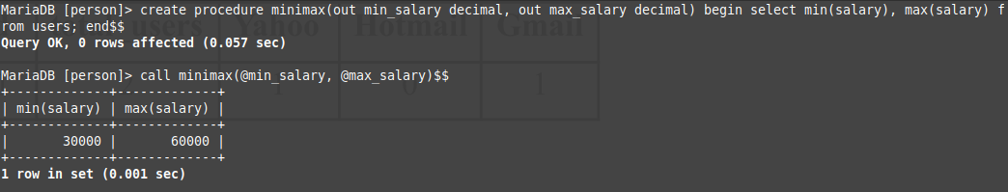

**Task 6:**

Creating triggers

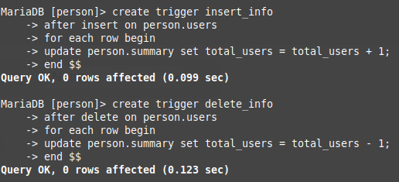

Inserting data into table calling procedure

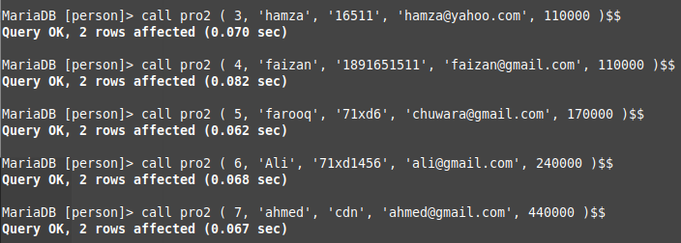

Two records already exist before calling procedures above

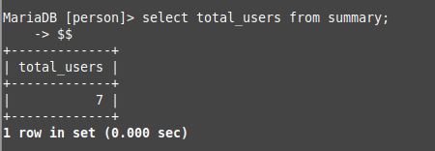

Deleting two records and checking total_users from summary table

